**Lab Assignment -1**

Name: Lakshmi Nikitha Kona Course: ASE

Student id: 16231555 Class id: 22

Date: 31-08-2016 Lab No: 01

**Objective**

The main objective of this assignment is to familiarize with the class diagrams which give an overview of the target system by explaining the various relationships between the classes.

**Scenario**

A user can create an account and add friends using their mobile number or email id. User can chat with any individual from his friends list; User can also create groups and invite his friends to join the group. In addition to that, media like images, video, location can be shared with friends and group.

**Description**

For the above scenario I have identified 4 classes User, User account, Chat, Individual Chat, Group Chat. Each user will have a single account and each user can have zero or more individual and group chat. Chat is the super class that can attach images, location, documents etc. Individual chat and Group chat are the sub classes that extend all the properties of the super class chat.

**Screenshot**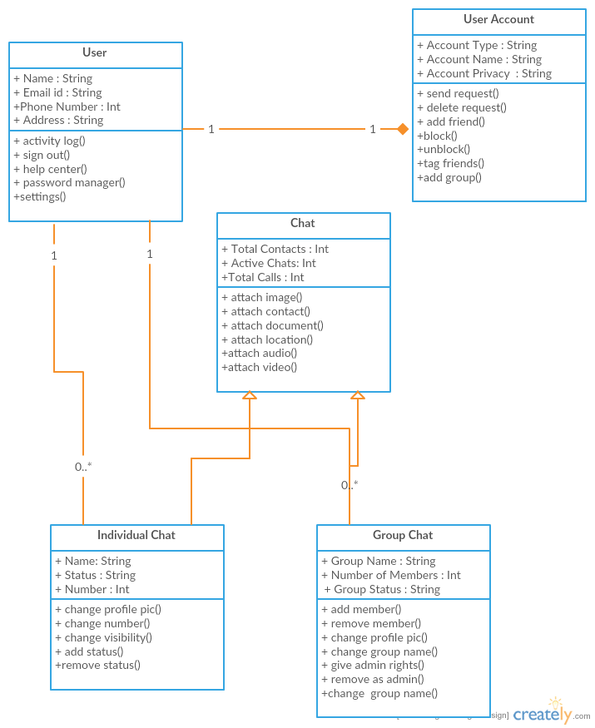

**Task 2:**

Create ZenHub Tool Account. Create a board, 3 iterations, at least 5 tasks and show the analytics graph.

**Description**

I have created 3 milestones as Increment 1, Increment 2 and Increment and have associated 5 issues

With each iteration summing up to 15 issues and based on the results analytic graphs have been generated.

**Screenshot for Increment 1**

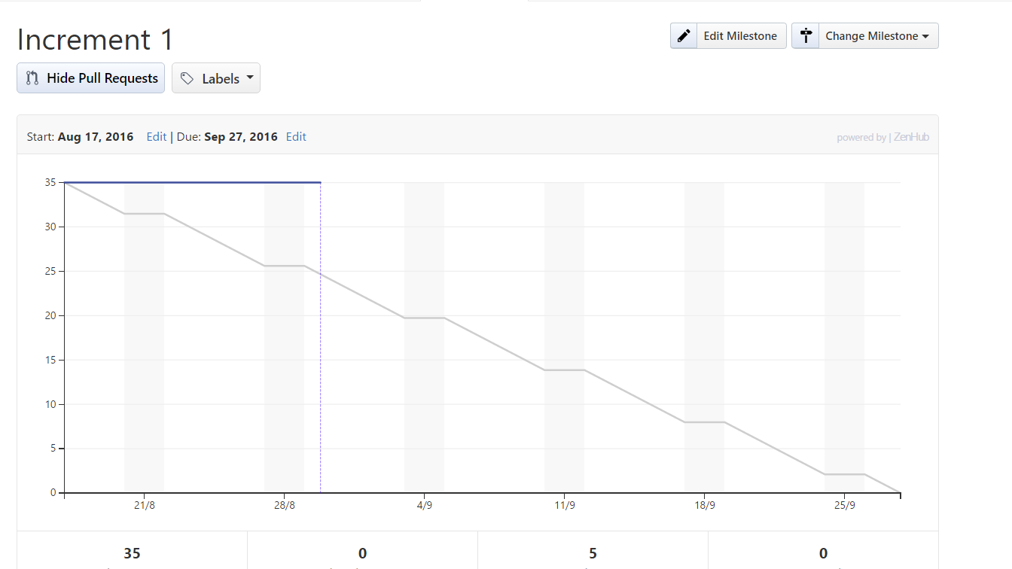

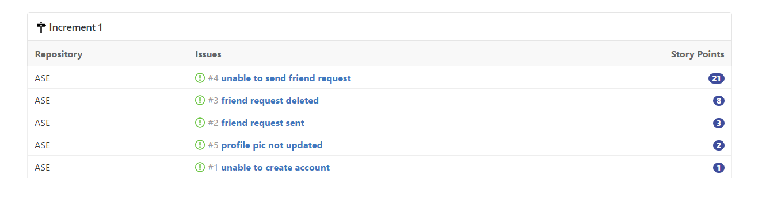

**Screenshot for Increment 2**

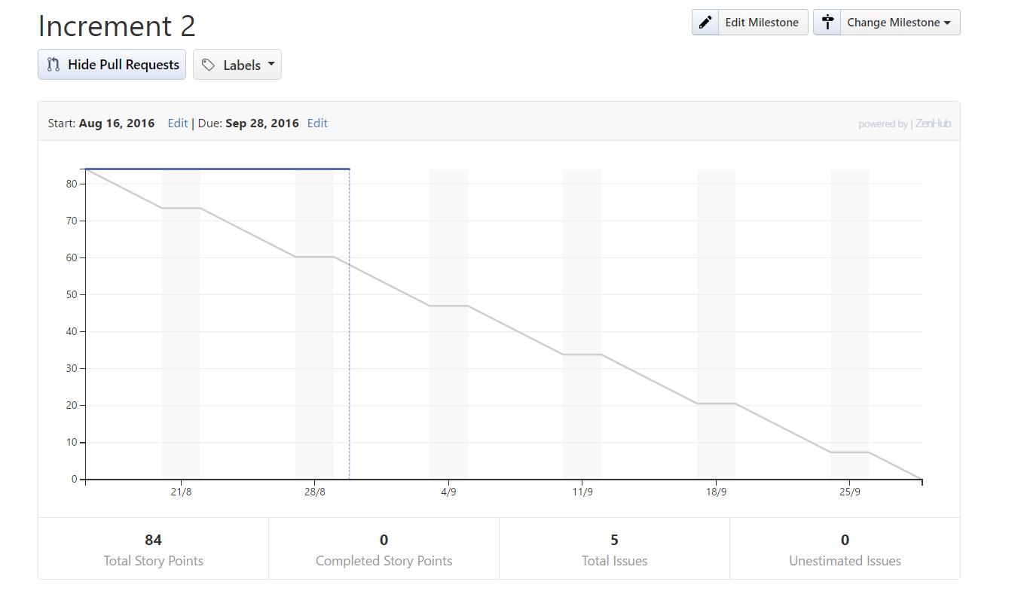

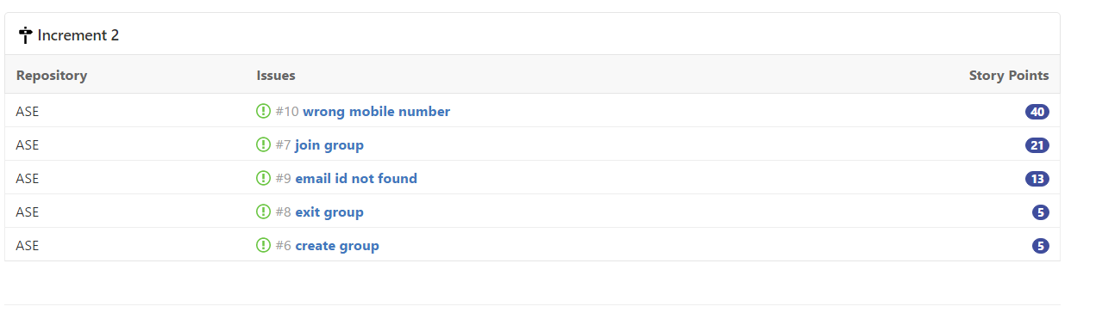

**Screenshot for Increment 3**

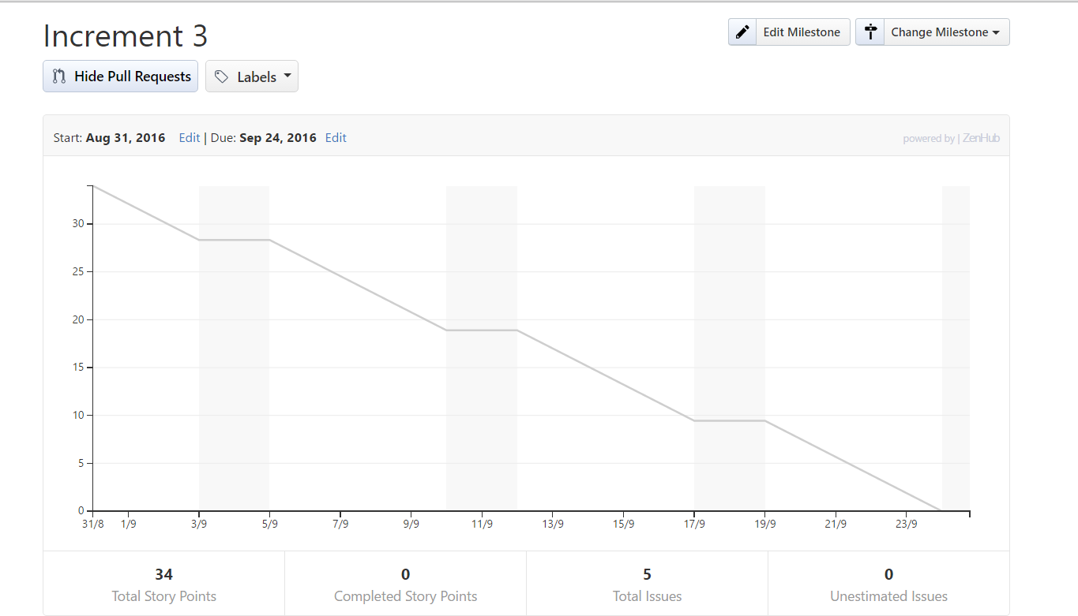



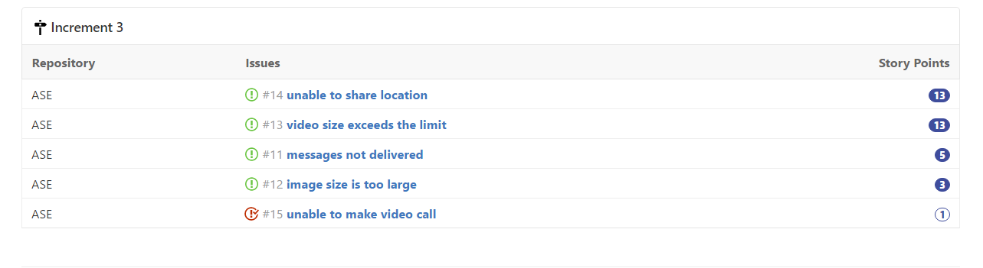

**Task 3**

Create Wiki page. Create a wiki page for your lab assignment through Github.

**Screenshot for wiki page**

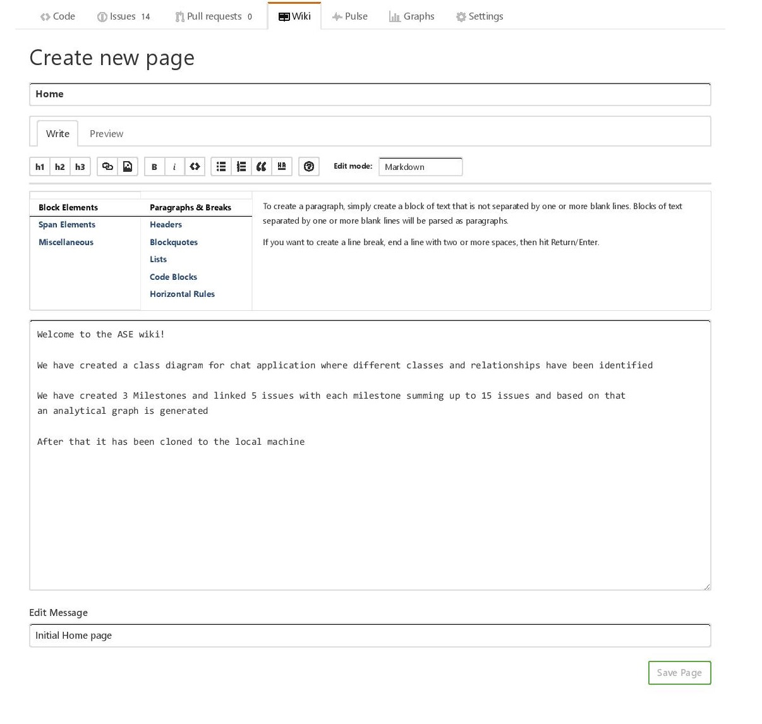

**Reference**

[**http://creately.com/**](http://creately.com/)

[**https://github.com/**](https://github.com/)